**IoT and Machine Learning based Smart Kitchen Stove**

Prachi Chouksey Sarthak Sugandhi Maunil Swadas Deep Khajanchi

MS in Software Engineering MS in Software Engineering MS in Software Engineering MS in Software Engineering

San Jose State University San Jose State University San Jose State University San Jose State University

***Abstract*--- The project on Smart Kitchen Stove is research towards modification of kitchen using IoT and Machine learning and exploration of solution to avoid disaster associated within kitchen**.

***Keywords*--- *IoT, Raspberry Pi, Gyroscope, Machine Learning, Python, Amazon Alexa, Amazon lambda, React, AWS cloud service, Mongo database***

1. Introduction

The idea of this project is emerged after the routine usage habits of kitchen stove. We are going to build a smart Kitchen stove which is controlled by Raspberry PI as a fundamental device. Basic function is to notify state of stove. Another feature is to track usage, its past and current usage is analyzed to make prediction for future data. In current burdensome and hectic lifestyle, there are possibilities to forget to turn cooking stove off after using. With the help of this product, customer will be able to avoid unwanted consequences in kitchen. If no one is at home and person forgot to turn it off then this product is the most useful one. We will implement functionalities to detect stove intensity using gyroscope reading and raspberry Pi computer. Customer will have access to Amazon Alexa to know current status of stove which is To track usage of stove, we will use machine learning to predict future usage based on past and current usage from mongo database. In another feature of usage prediction, one can have idea about resource usage if it needs to be decreased or not. Connected mobile application will have statistics showing user’s stove using habits. We have plan to continue this project to enhance more functionalities within this feature.

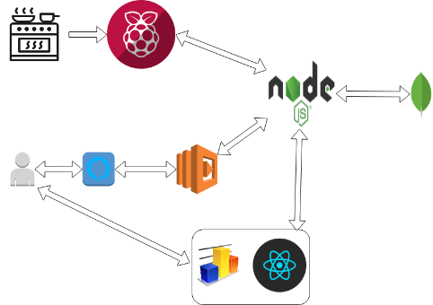

1. Project Focus and Process Flow

We have developed a product named “Smart Kitchen Stove” that is based on IoT and it is interactive with user on which one can rely. This product, which is serving as a companion to people who keeps forgetting things related to house and needs to keep tracking. Primary function includes on and off status of kitchen stove. This product is also inclusive of dashboard and graph for usage from where customer can easily compare data from past and current. When user asks Alexa for stove

condition, it responds user if it is on or off. For usage consumption, implementation of Machine learning has been carried out.

1. Technologies stack implemented
2. Internet of Things

Raspberry Pi computer and Gyroscope

With the raspberry Pi and a Gyroscope, it is possible to measure the rotation. Gyro has to be tracked over time to calculate the current angle.

This angle denotes intensity of stove. Reading of 0 means stove off and increment of angle increases heat intensity till reading of 8, which means highest heat.

1. Machine Learning- Python

To train past data to get predicted usage, we have implemented machine learning regression model to predict the bill based on the rotation value of the smart stove. We have prepared monthly dataset for total counts of the stove rotation and bill amount. Then we are forecasting bill for current month based on current value of the stove rotation.

1. Mongo Database

We have used mongo DB to store previous current reading and based on these reading, we have displayed usage graph. A record in MongoDB is a document, which is a data structure composed of field and value pairs. MongoDB documents are similar to JSON objects. The values of fields may include other documents, arrays, and arrays of documents.

1. Amazon Alexa

We have created a skill in amazon Alexa in order to make our product more interactive. We have introduced different intents including built-In intents for various requests and questions from users. In each intent, there are sample utterances which is asked. To respond these requests, Alexa has been linked with AWS lambda.

1. AWS Lambda

We have used AWS Lambda, a serverless platform to invoke Alexa skill. Lambda manages invocation of skill, intent request and respond to user.

AWS Lambda is an event-driven, serverless computing platform provided by Amazon (Amazon Web Services). It is computing services that runs code in response to events and automatically manages the computing resources required by the written code. Lambda is used to build on demand and smaller applications that are responsive to events and information.

1. React -User Interface

Using React, we have created dashboard showing consumption data basis on monthly cycle. Dashboard also shows predictions for consumption.

React makes it painless to create interactive UIs. Design simple views for each state in application, and React will efficiently update and render just the right components when data changes.

1. Use cases
2. John and Anny, they are students and they are having hectic schedule all the semester. They hardly manage time to cook. In this case they prefer this product to be notified about their stove condition and consumption.
3. Julie, she is a working woman and a mother who has job in a corporate world. She has many roles to play. She might forget about stove as she is always occupied in her work.
4. Allen, he is old aged person and keeps on forgetting things. In the past he had faced two unwanted situations in kitchen. This product can save him from being in such situations next time.
5. Future Enhancements

In continuation of this project, we are planning to enhance stove functionalities in near future too. We will add function of usage warning if it exceeds or near to maximum consumption units. Moreover, automatic heat intensity according to food, automatic stove off functionality and email notification to user are our future implementation goal within this product.

1. Conclusion

To conclude, instead of suffering from all disasters in the kitchen, we have implemented Smart Stove to prevent them. We have decided to continue more research and investigation on this project.

1. Acknowledgement

We would like to thank Professor Rakesh Ranjan for advice, support and opportunity of this significant platform to showcase our project.

1. Project Repository

<https://github.com/SJSU272Spring2019/Project-Group-16>

1. References

* <http://ozzmaker.com/guide-to-interfacing-a-gyro-and-accelerometer-with-a-raspberry-pi/>
* <https://machinelearningmastery.com/make-predictions-scikit-learn/>